Module 6 : Visual Analytics

1. Dual Combination Chart: Create a chart to display the Shipping Cost and Profits of superstore for different Months. Use Global Superstore.xls data source.

Output:

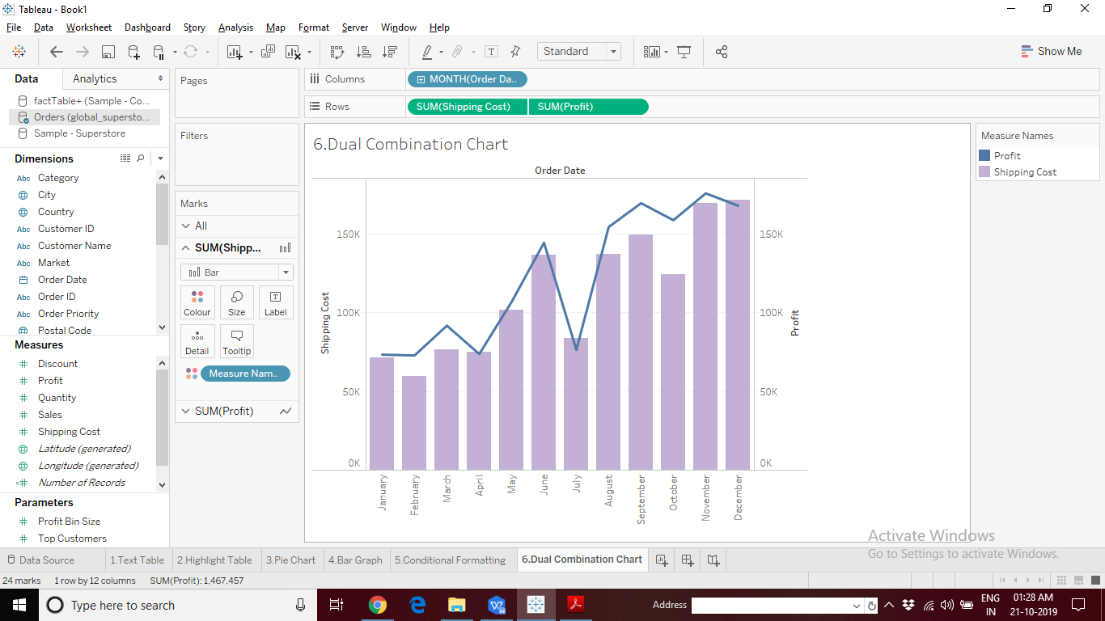

1. Data Interpreter: Using the “AMZN Stock.pdf” input data source, observe the data on the data grid before and after using the “Data Interpreter” Option. Explain the differences.

Hint: Get connected to page 2.

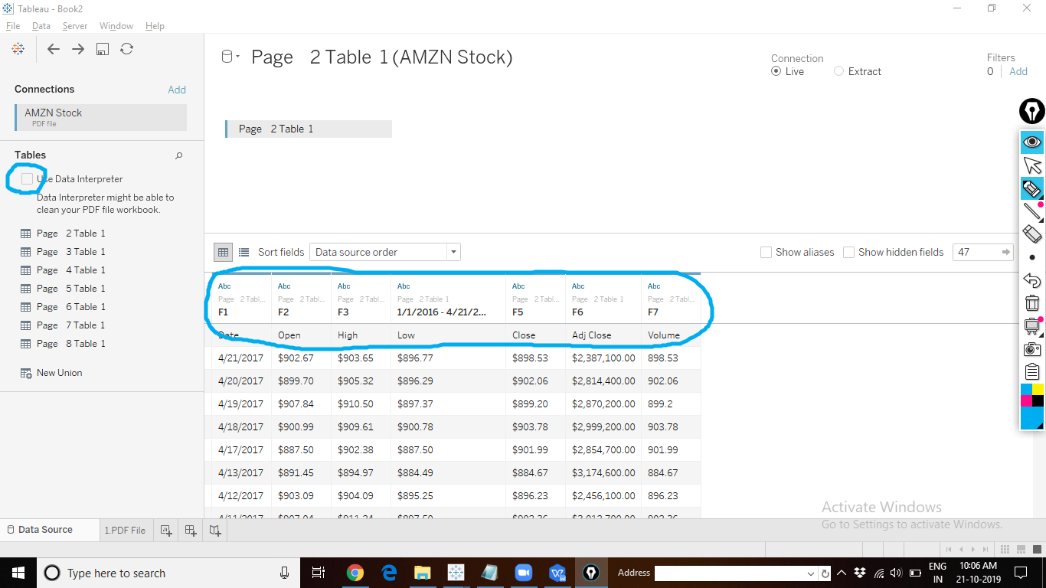

Output:

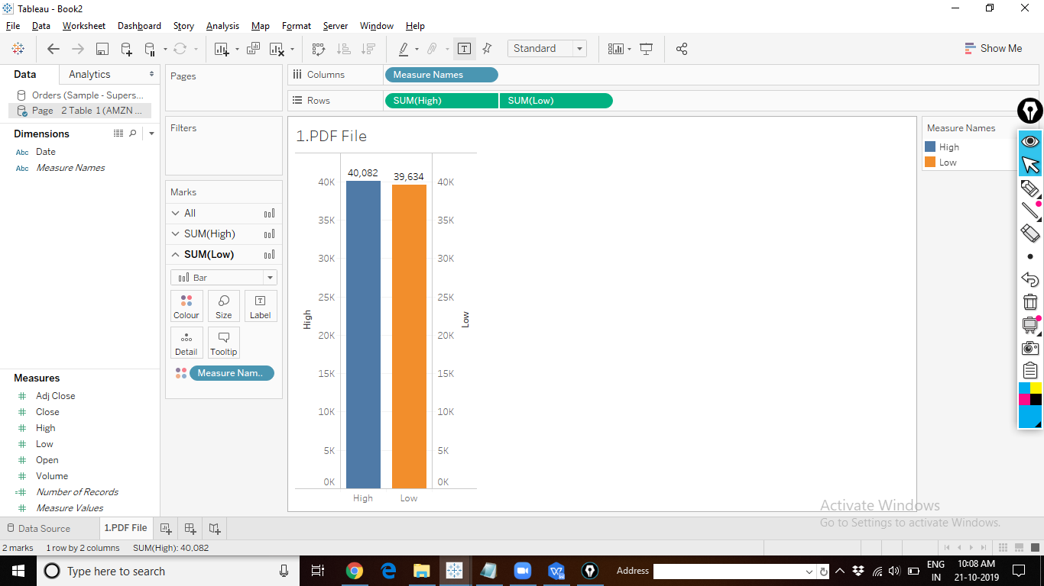

1. Bullet Graph: The Product Manager of Coffee Chain needs a report showing all the products and information on which products could meet the “Sales Target (Budget Sales)”. They will use the report to check how to improve sales.

Output:

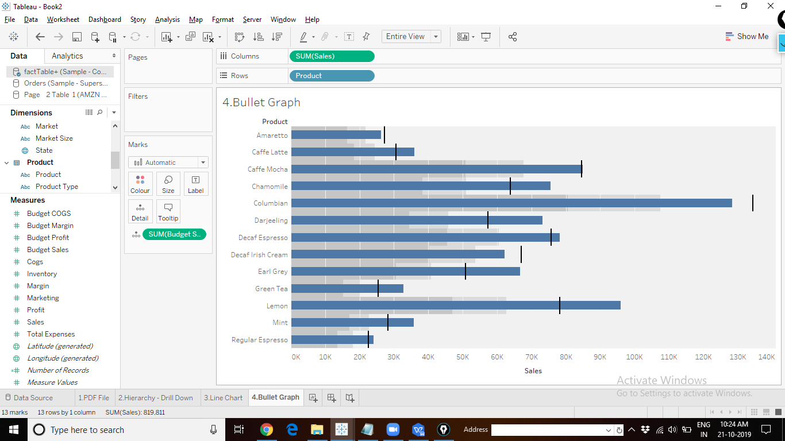

1. Tree Map: Create a chart to show Profit and Sales information for distinct products available. Use Product Id.

Output:

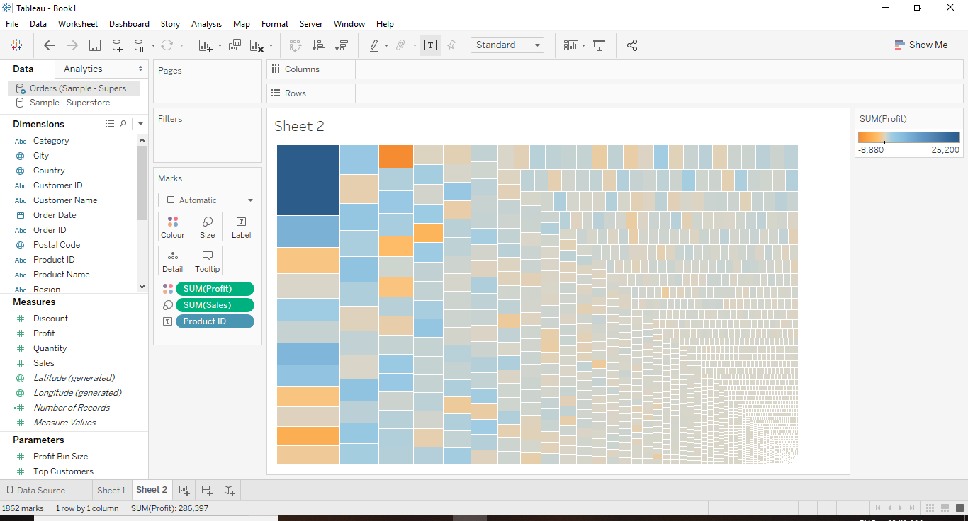

1. Reference Band: Product Manager of Coffee Chain would like to analyse the product sales information. Use reference bands to help him group the data into different categories as “High Sales”, “Medium Sales” and “Low Sales” products.

Output:

